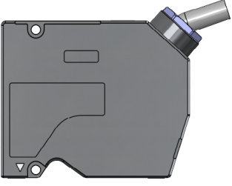
SGI030/035
Sensor head

Specifications
Model |  | SGI030/035
Reference distance (RF) |  | 30mm
Measuring range |  | -5mm-5mm
Light source | Light source wavelength | 655nm
Light source | Laser class | Class II
Light source | Laser output power | 5mW
Laser point diameter (Light dot size) | Small laser point | Φ60μm
Laser point diameter (Light dot size) | Wide laser point | 60*400μm
Repeatability^{①} |  | 0.05um
Linearity |  | ±0.05% F.S.
Temperature characteristics |  | 0.01% F.S./℃
Sampling refresh rate (Hz) |  | 1/2/5/10/20/50/88kHz (Choose from 7 levels)
I/O | Communication port | 1 100Base-TX/1000Base-T Ethernet interface, 1 RS485
I/O | Analog output | 1-channel analog outputs, supports analog voltage and analog current switching
I/O | IO input | 2 channels, timing, zeroing and single-ended encoder function multiplexing.
I/O | IO output | 4 channel, determines status of output.
Operating temperature |  | 0-50ºC
Storage temperature |  | -20-70ºC
Working humidity |  | 35%-85% no condensation
ESD protection |  | Contact discharge 4kV, air discharge 8kV, conforms with IEC61000-4-2 standard
EFT protection |  | Power port 2kV/5 or 100kHz, signal port 1kV/5 or 100kHz, conforms with IEC61000-4-4
Bumps |  | 50Gs/3ms on each axis, conforms with IEC 68-2-27 Ea
Vibrations |  | 10Gs (10-500Hz), conforms with IEC 68-2-6 Fc
IP level |  | IP67, conforms with IEC 60529 standard
Dimensions (mm) |  | 90x75x41
Data cable (wiring) model |  | SCB-GICAM-HA1-3m/6m/10m
Weight (Including cables) |  | 324g
Note: ① Obtained from 4096 tests at reference distance.

Product Dimensions
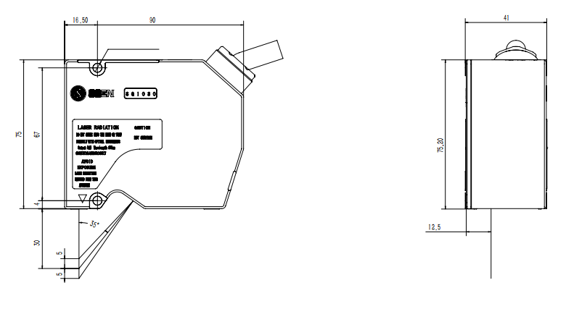
2-Ø4.40 through mounting hole position
